1. If you want to view reports of all the traders then you need to click on Report (View Traders Report) **CLICK HERE** button on the middle left of our Dashboard. After clicking on it will redirect you to Oracle Dashboard from where you can login with your username and password.

* Invalid login credentials.

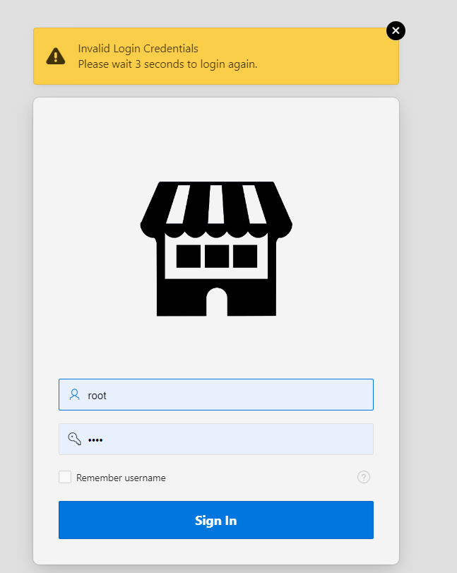

* Valid login credentials.

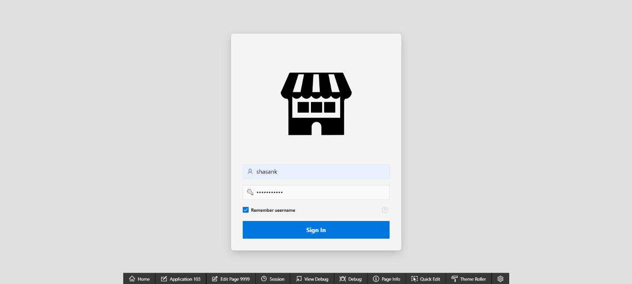

1. After logging in with correct credentials as Admin you’ll have access to the different reports of shops, products, reviews and many more information like highest selling shop, top selling products etc. through different graphs.

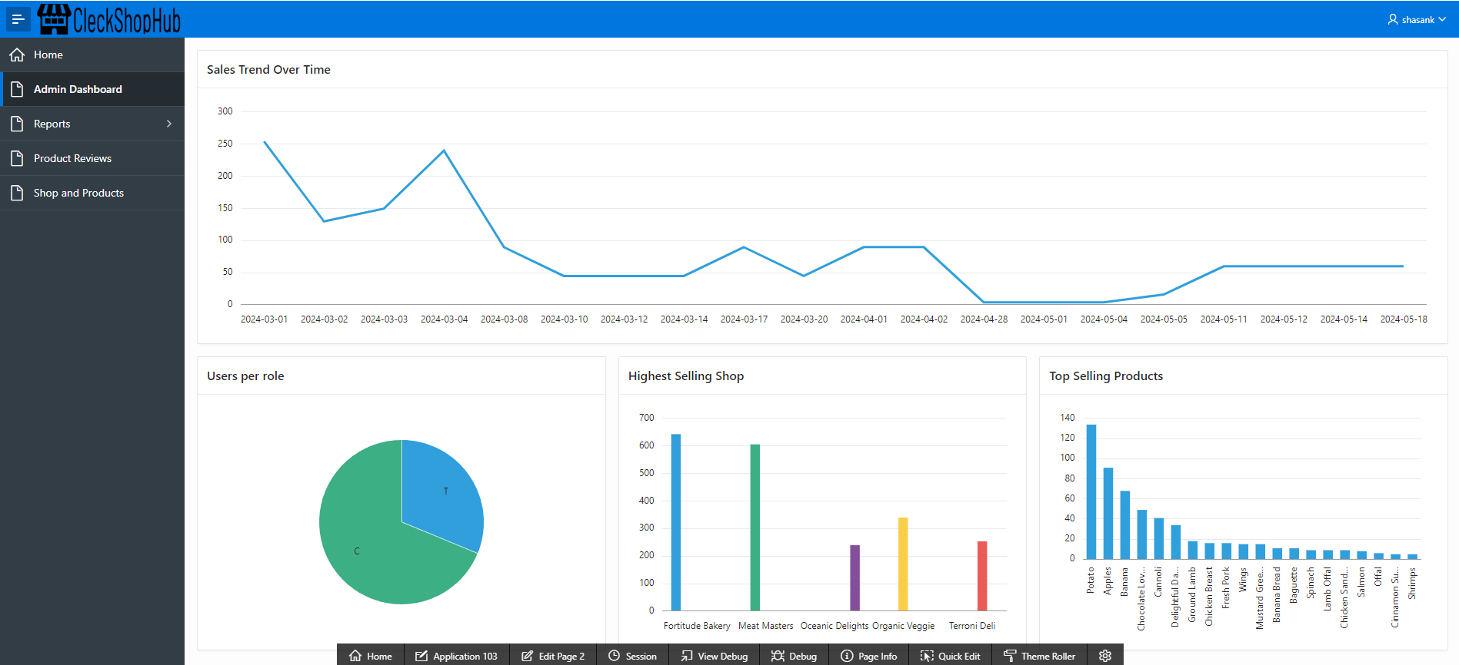

1. ADMIN_DASHBOARD displays sales over time, user role, highest selling shop and top selling products.



1. Product Reviews display all the details about product and it’s reviews in master- detail form where the master form is Product whereas the detail form is Reviews of the Products.

1. SHOPS_AND_PRODUCTS display all the shops and their products in master-detail page. The shop is the master form and products are in the detail report.

1. WEEKLY SALES REPORTS OF SHOPS display the sales and income of all the shop in past 7 days.

1. MONTHLY SALES REPORTS OF SHOP display the sales and income of all the shop in past month.

1. You can logout by clicking on username and then Sign out.

